# **Algorithmic Digital Marketing**

| **Summary** | https://codelabs-preview.appspot.com/?file_id=1RZSOWFTn5qPB5A2U5fiBeLl0-Rs-kOlatYhz8wWGbNE#0 |
| --- | --- |
| **URL** | https://www.shiseido.com/us/en/ |
| **Category** | Web |

# 

# About Company:

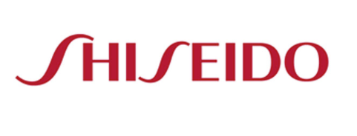

Shiseido Company, Limited is a Japanese multinational cosmetic company.

Revenue: 920.9 billion JPY (2020)

# What is the product?

Shiseido Company, Limited is a Japanese multinational cosmetic company.

Its product categories consist of: skin care, makeup, body care, hair care and fragrances.

They have products for men and women. Apart from male and female segmentation they

have segmented products into categories such as antiaging, oil control, lifting & fitting

to make it easier for customers to find the product.

Alternatives: the body shop, colourpop, ipsy, mac cosmetics

Personalised Search: to find serum - take a quiz

Moisturizer - Find your formula

Eye care finder - start now

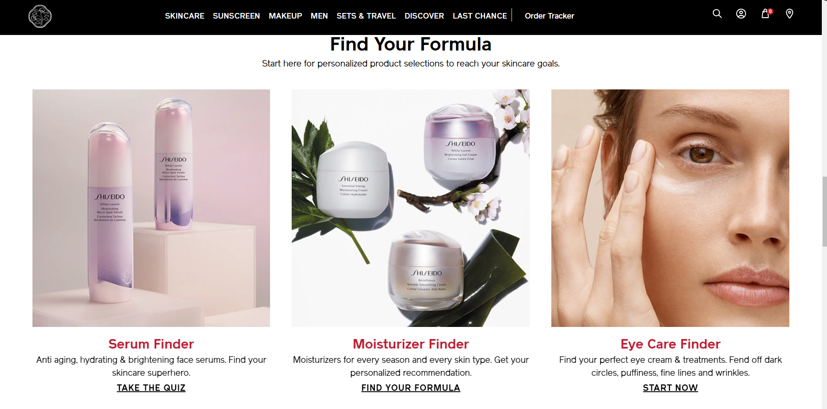

# How are they selling it?

Business to consumer through their own website and departmental stores

and business to business through sephora, ulta beauty, macy’s, target, walmart,

Amazon, wee

# How is it priced?

It has the option to select size : 50 ml and 75ml based on it prices vary.

Prices are round up value. Prices change with the quantity.

They are giving options for Auto-Replenishment :Receive 10% off and free standard shipping with each replenishment order

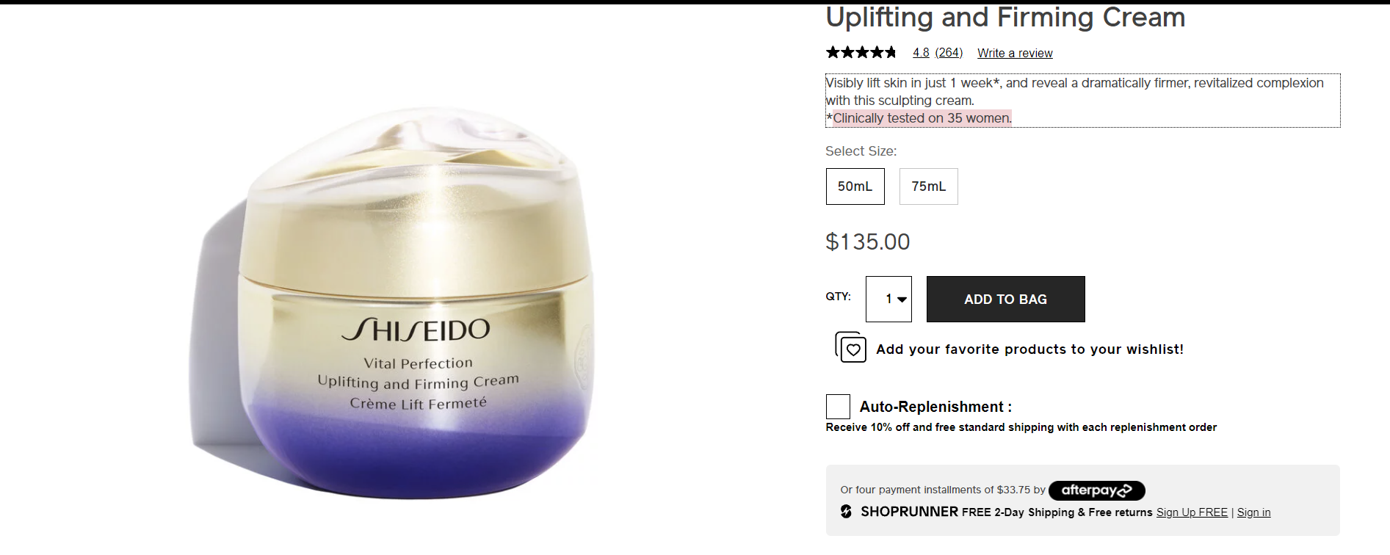

# What promotions are they using?

When you go on the website within seconds you are able to see this page: promotion mentioning 15% off on $100 purchase.

Deluging customers into spending $100 and getting their email address to send further promotions.

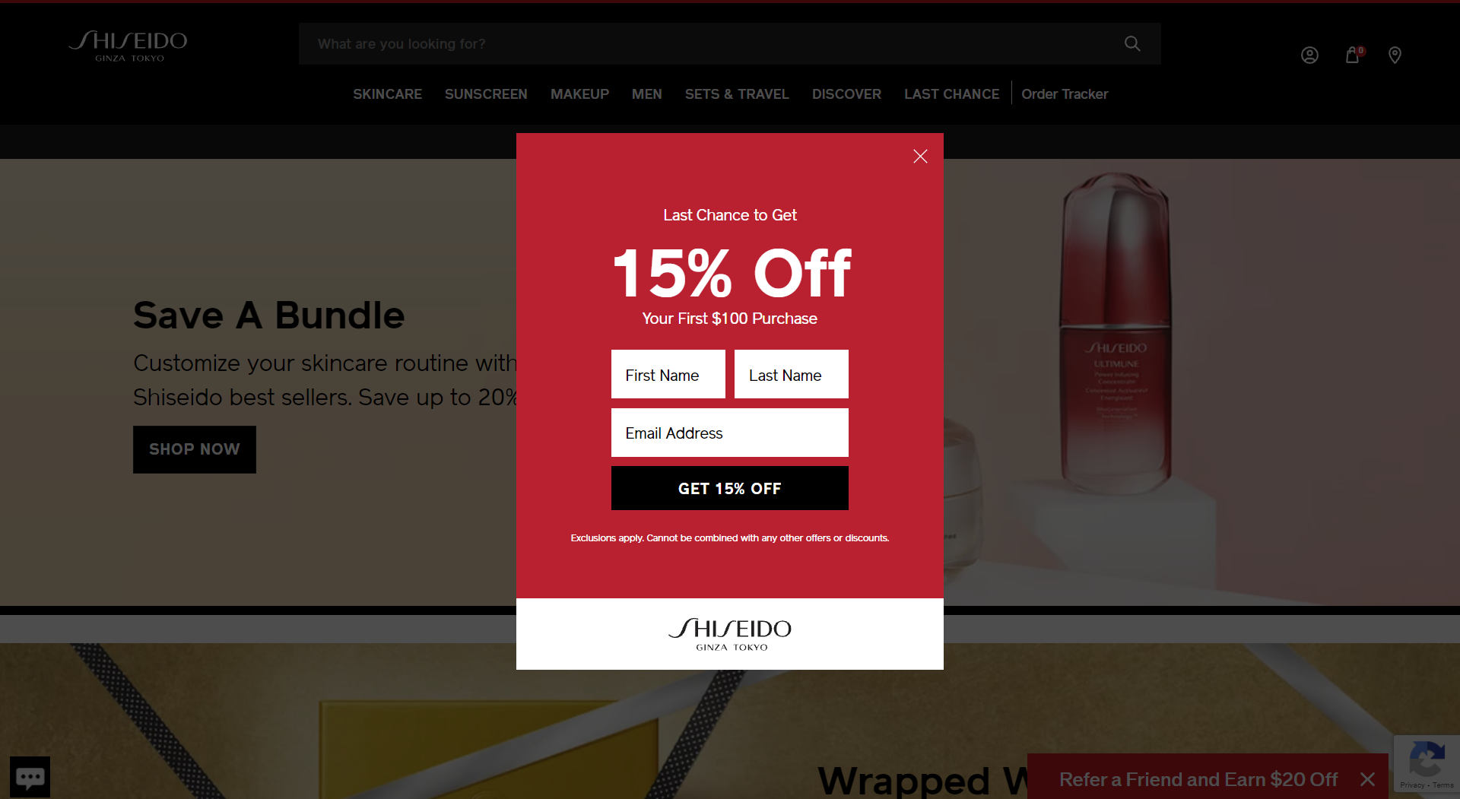

As soon as we open a page we get products from their own brand shiseido. Self promotion and at button it says refer a friend and earn $20 0ff

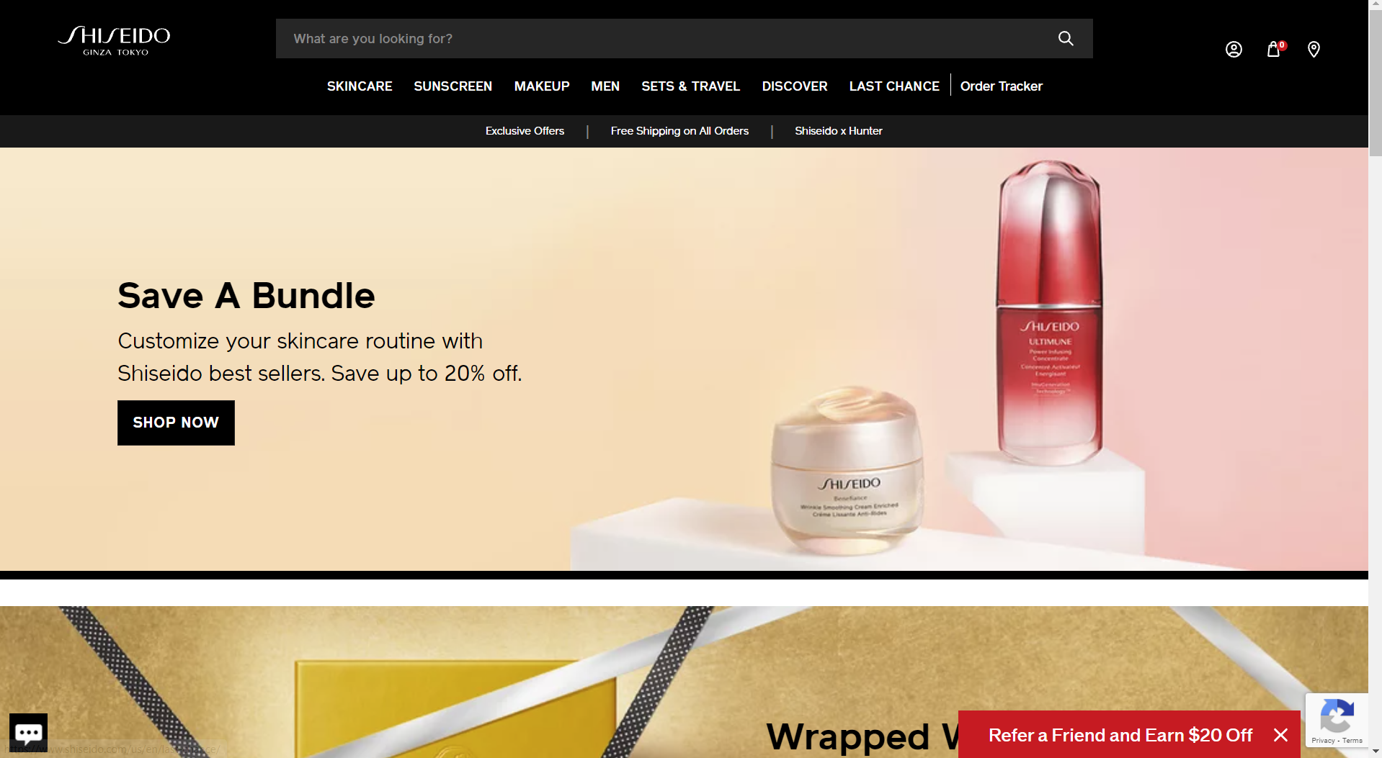

Shop gift sets : making sale by selling it together

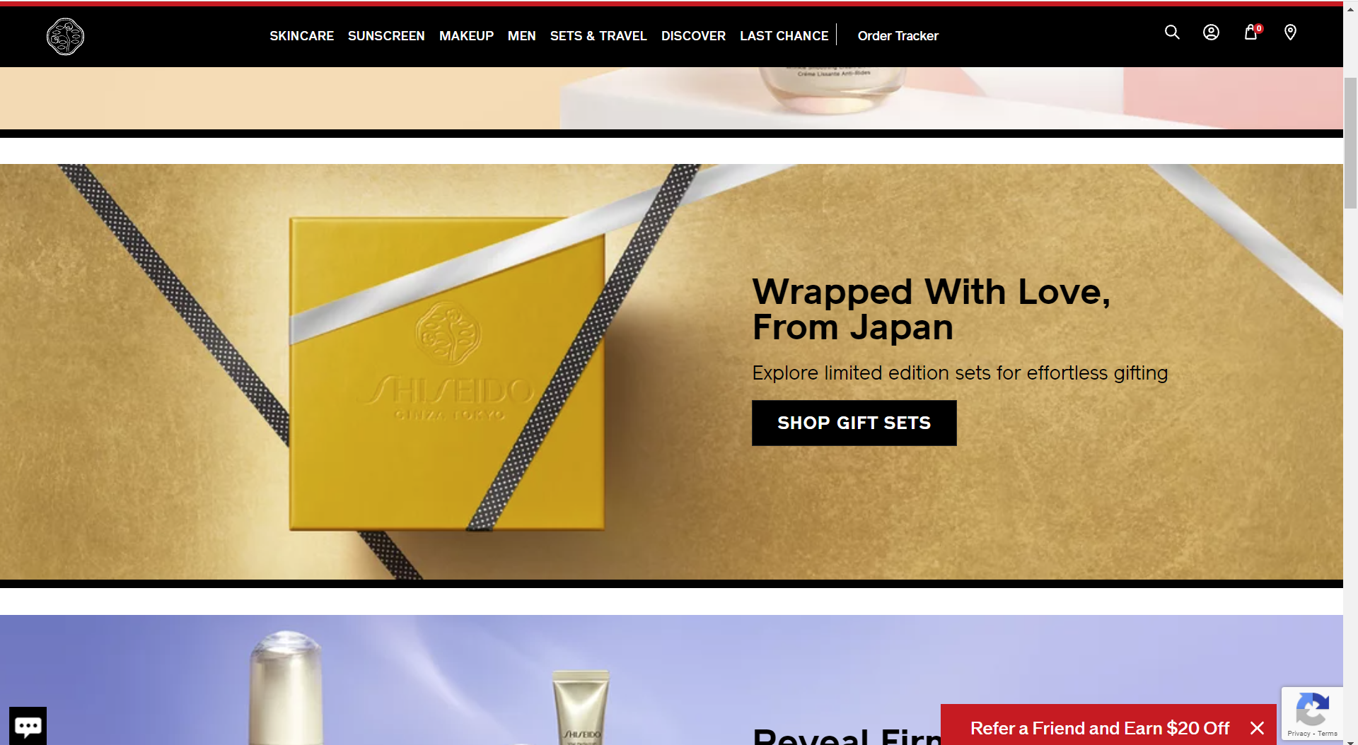

Doing promotions by tagging : award winner, best seller, limited edition,selling fast

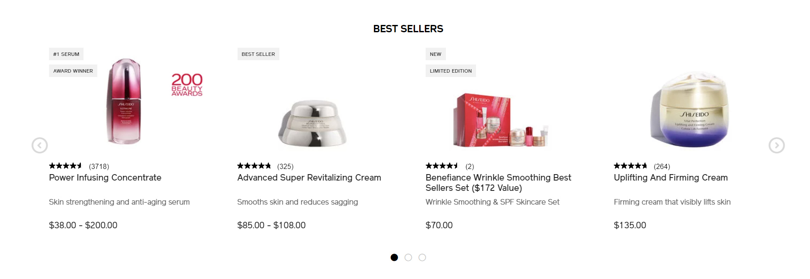

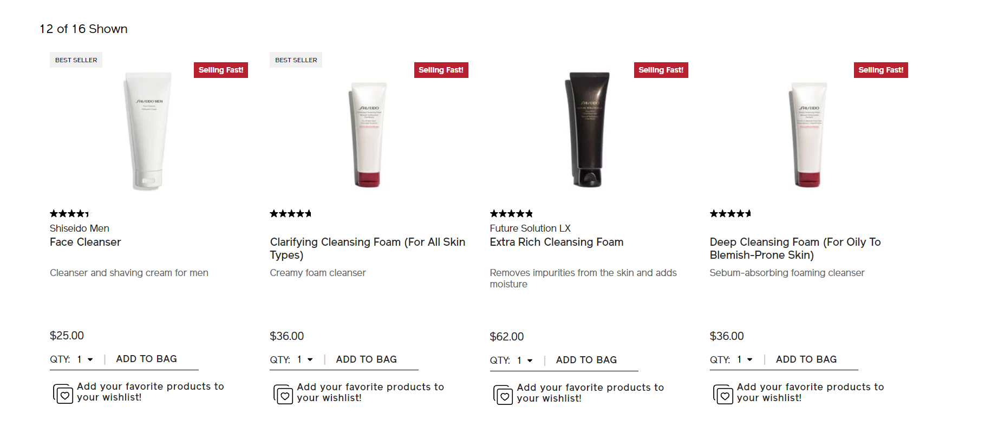

They are providing : Free shipping with any purchase. Free samples and free returns with every order.

Website is high on promotions: If you go to buy any product it gives more information as: clinically tested on 35 women, this gains confidence of customer



When you add a product to cart. You get recommendation in cart stating you may also like:

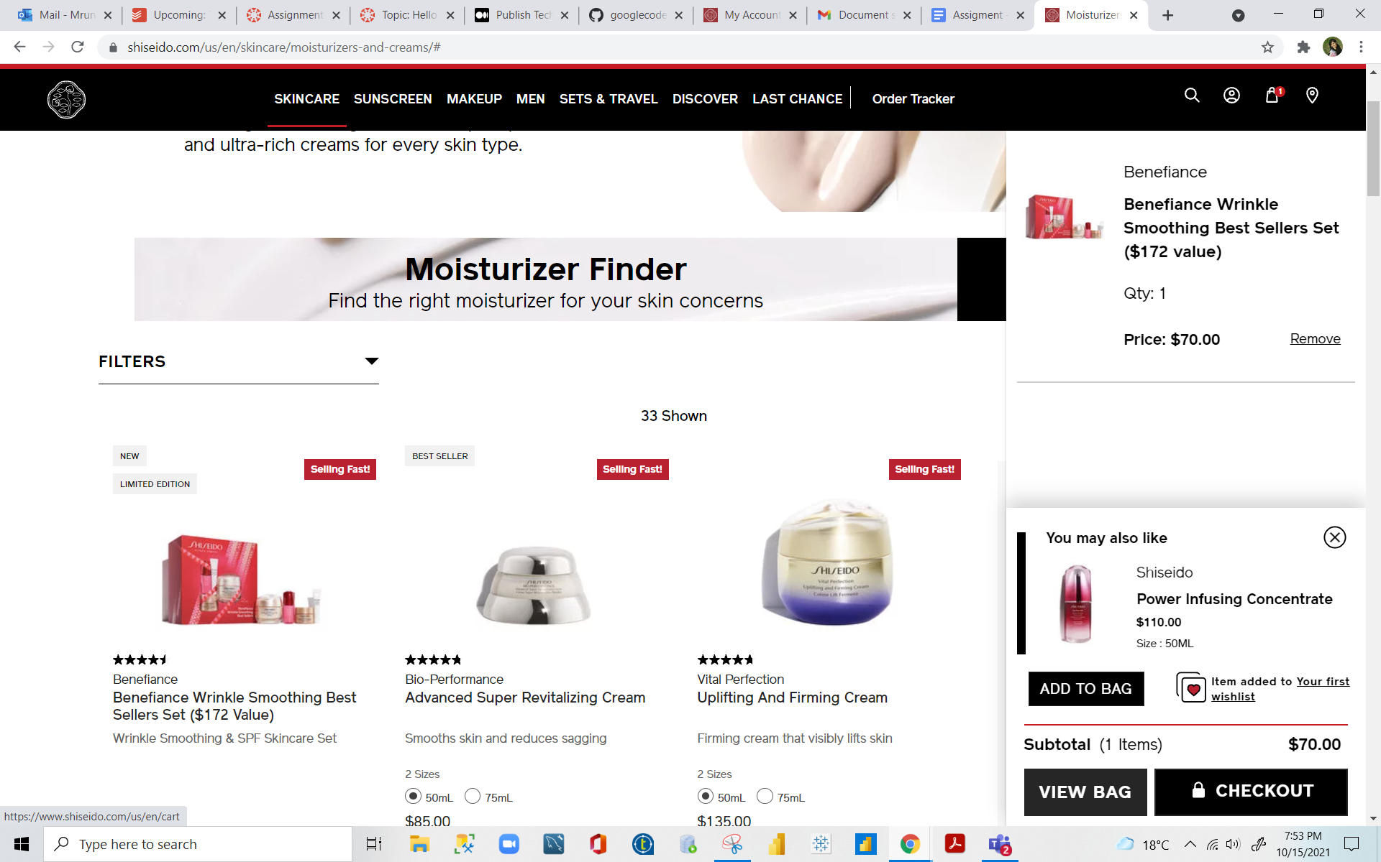

# What algorithmic marketing services are they using?

Algorithmic marketing services : promotion and recommendation

Recommendations: after viewing any product website recommends “customer who viewed this item also purchased”

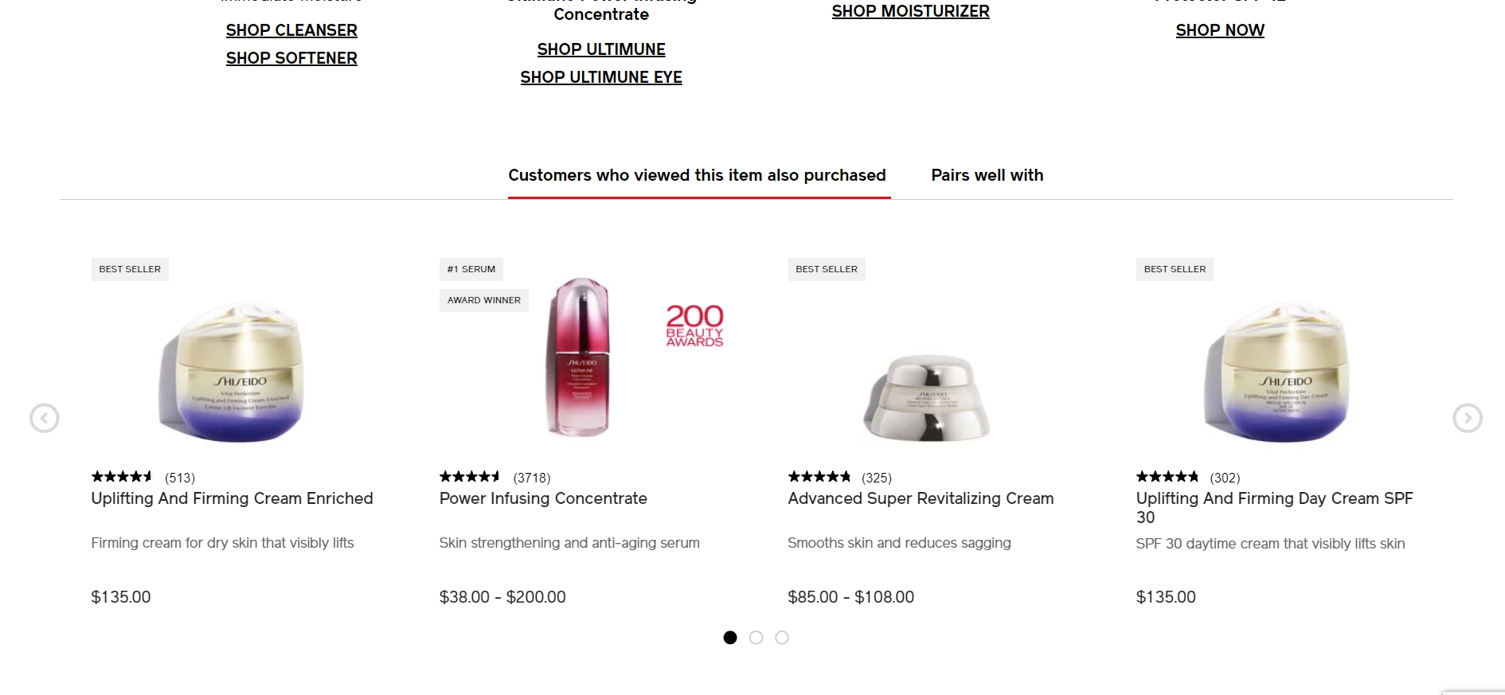

# What datasets do you think you will need to build these algorithmic services?

* Promotions:
* Customer personal details like contact number, mail id to send personalized promotions.
* Advertising:
* Product details - for new item launches or clearance sale.
* Customer profile- to target audience for better results based on search history that stores in cookies and cache. (Particularly Facebook, YouTube, Instagram)
* Search:
* Product catalog
* Recommendations:
* Customer purchase history
* Pricing:
* Seasonal data, Product expiration date
* Assortment:

**a)** **How frequently data will change?**

Product details will remain the same. Price data fluctuates according to demand/supply and varies seasonally. Recommendation will change with time and Customer location (When customer changes his/her location, recommendations keep on changing accordingly).

**b)** **How would you store this data?**

S3 Buckets because unstructured data can also be stored easily like images.

# Review jobs/career site and search for Data/Data science positions. After review of the site, what technologies and programmatic services is the company using?

The following Technologies/Tools are being used :

* There are no open data/data science positions. Following are the responsibilities for the analyst position.
* Tools for Forecasting to analyze business trends across the brands.
* data collection, tagging, reporting and analysis for their ecommerce websites.
* Analytical insights to improve site performance.
* Dashboard development based on stakeholder requirement.
* Need to be updated in web analytics tools such as google analytics etc.

The following programmatic services are being used:

* Recommendations.
* Promotions.
* Advertisement.

# How is the company tracking visitors?

* By using google analytics company tracking their visitors.
* Total visitors for website during Aug 21st – Sep 21st are 644.19K
* Average visit duration is 2.47 minutes
* Top 5 countries who visited this website are:
* United states - 53.25%
* Japan - 20.49%
* Canada - 5.68%
* Singapore - 3.53%
* Australia - 1.91%

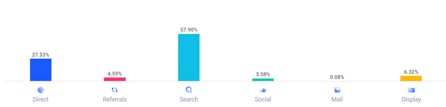

* Traffic source for website: